What is a Bone Marrow?
FAQ About Bone Marrow Biopsy
Bone marrow is found in the hollow part of most bones. It helps form blood cells.
What is a Bone Marrow Biopsy?
It is when soft tissue is removed from the bone marrow, or inside of the bone.
How is the test performed?
Usually the biopsy is taken from the pelvis. The patient will lie on one side; the site will be cleaned and then numbed. After the site has been numbed the Physician will insert the needle until it meets the bone. The middle of the needle will be removed and the hollowed needle will move further into the bone to get a very small sample. Then the needle will be removed and bandages applied.
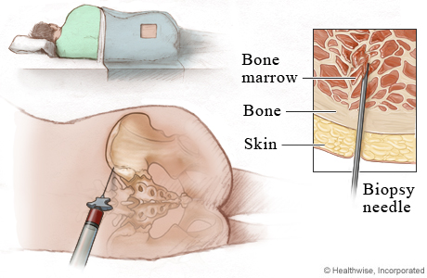
In some cases a bone marrow aspirate will need to be performed. The procedure is the same as describe above except before the sample is taken a syringe will be attached and liquid bone marrow will be taken.
What will the test feel like?
You will feel a stinging sensation when the numbing medication is injected. When the biopsy needle is inserted you may feel dull pain or pressure. It is not possible to numb the bone and you may feel a sharp pain when the liquid aspirate is removed. Not all people experience such pain.
Why is this test performed?
This test may be ordered if you have an abnormal red cell, white cell, or platelet count. It is also used to diagnose leukemia, anemia, or other blood disorders.
What are the risks of this test?
There are risks of bleeding at the site. More serious complications, which are rare, include infection and serious bleeding.
What should you tell your Physician before having this test?
You should tell your doctor if you have
- any bleeding problems
- if you are pregnant
- your current medications

